BassPro HCX Migration Process

Contents
Starting Replication (RAV) 2
Switchover 5
Possible Issues 6

Starting Replication (RAV)

- Locate the virtual machines that are going to be in the migration group. Make note of what vCenter and cluster or folder they’re in.
- Open the HCX manager plugin by clicking the menu > HCX
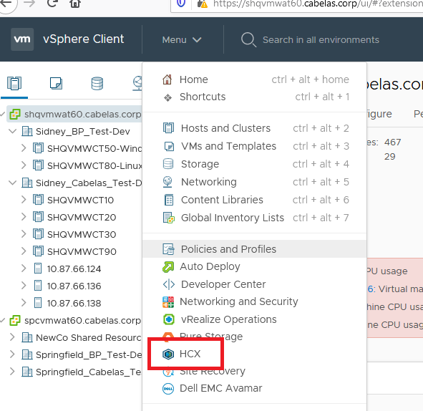

- Select Migration and then click Migrate
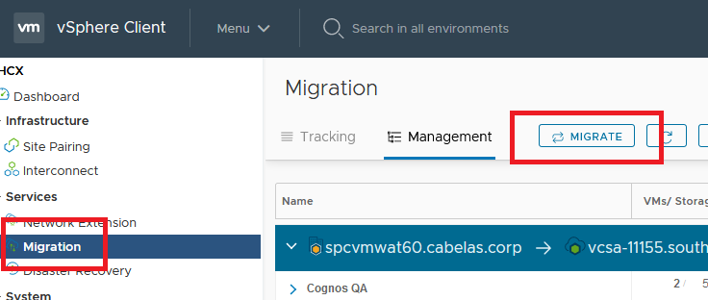

- Select the connection depending on which vCenter the servers are being managed by.
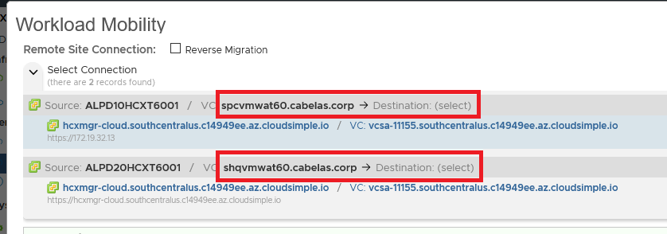
- Give the migration group a name, then browse to the cluster or folder and select the servers, then click add.
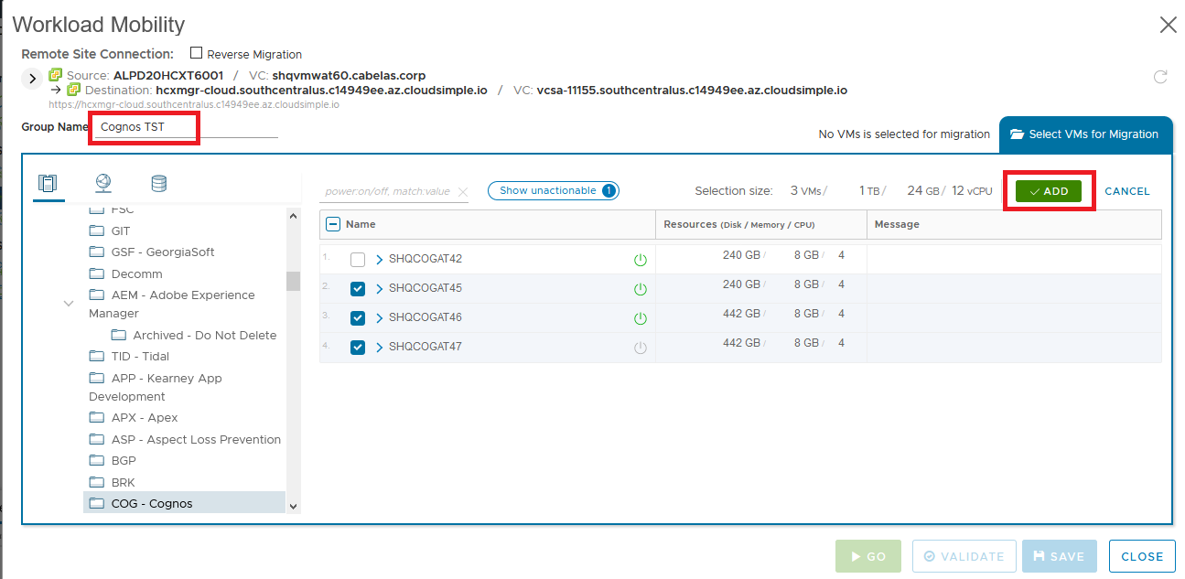

- Fill in the default options for the servers. The default options should be:
  - Destination Compute Container: Workload
  - Destination Folder: Workload VMs (or the folder that corresponds to what they have on prem)
  - Destination Storage: vsanDatastore
  - Virtual Disk Format: Thin Provision
  - Migration Profile: Replication-assisted vMotion (RAV)
  - Schedule – Set a schedule into the future a few weeks. This schedule is used to prevent the machines from switching over until the actual window. During the window the schedule will be ignored to trigger the failover
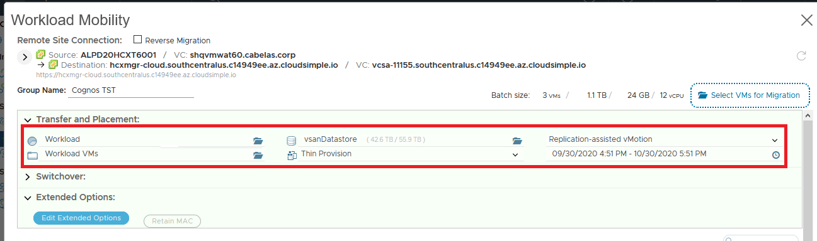

- Verify the destination network by expanding each VM for migration and checking the network adapter. Usually if the extended network exists on the AVS side, it will be preselected for you. If it isn’t, look for the corresponding network on the AVS side. It should match the source network with a L2E prefix and random suffix. For example: 0612V_D002_Dev02 is L2E_0612V_D002-Dev02-612-ea3ff090 on AVS. Some networks may get truncated if they have long names. If you can’t find anything that matches, likely the network will need to be extended into AVS.
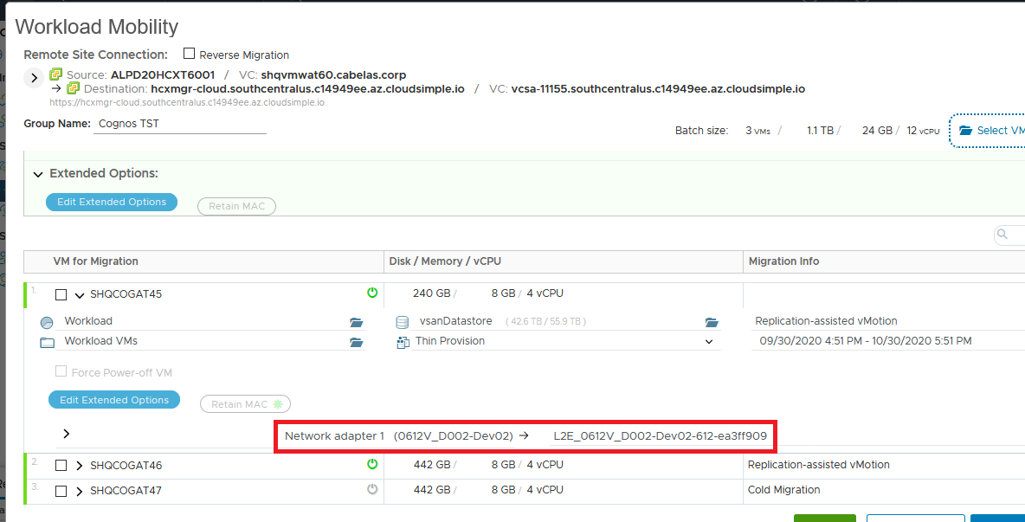

- Double check everything. Once validated you can either click save to save the migration group as a draft, or click Go to start the process. This will start replication and get the servers synchronized to a shadow VM in AVS, but will not switch over the VMs until the scheduled time, or the schedule is removed/ignored.
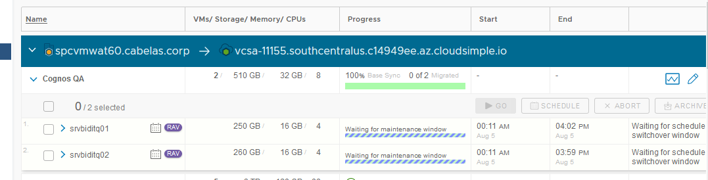

Switchover

- When you’re ready to switchover during the migration window, find and expand the migration group, select all the items in the group, then click the schedule button.
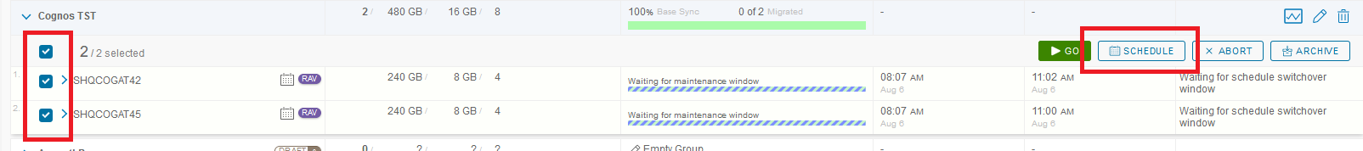

- In the schedule window, check the Ignore failover window and start migration as soon as possible, then click Apply. This will kick off the switchover within a minute or two. You’ll have to expand the group to see the switchover status of each VM. The process will flip back and forth from Base Sync to Switching Over several times before the final switch over process completes. Switchover can take a long time for larger VMs, anywhere from just a few minutes to an hour or more.
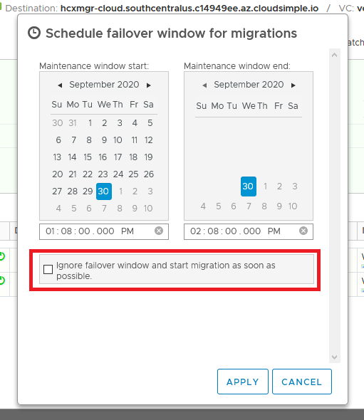

Possible Issues

- Error about External device(s) detected on VM. This is a bug in the release of HCX that BassPro is running. The workaround is to edit the settings of the VM and clear the “connect at startup option” on the CD/DVD drive(s), if permissions allow. If the error is still happening, change the device to use a datastore ISO file as well.
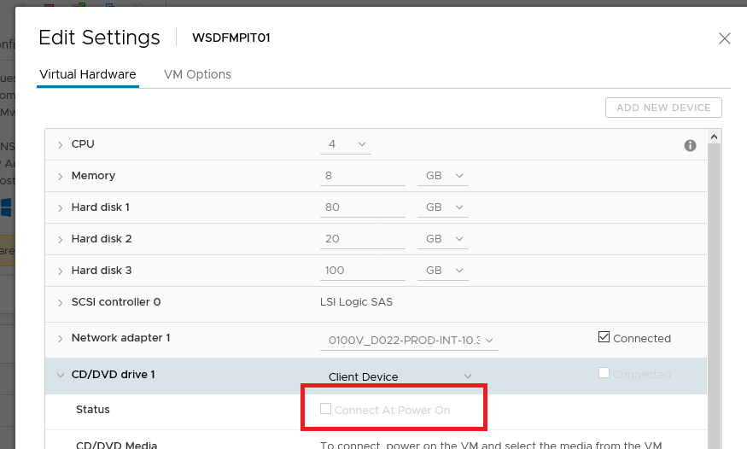

- The VLAN is not extended. As mentioned above, if the network is not automatically populated and/or not available in the list, it likely means the network has not been extended into AVS. You’ll need to reach out to the Bass Pro team and have them extend the VLAN. When its extended it should be available in the list for you to select. Note: some VLANs have longer names and may be truncated. The networks on the AVS side will be prefixed with L2E_ (signifying it’s a layer 2 extended network), and then suffixed with a random GUID.
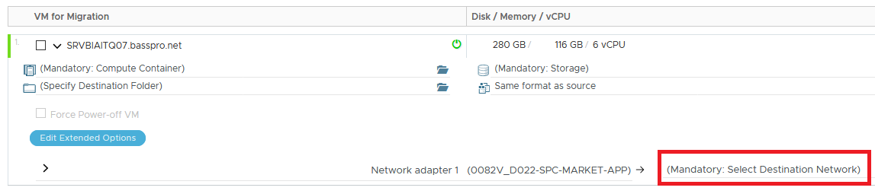
Example AVS extended network names:
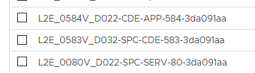

- Error about SCSI bus sharing – this has come up on some servers that are part of a cluster or were intended to be part of a cluster and do or did have shared disks. Discuss with the Bass Pro team, if the server is not in a cluster and doesn’t have shared disks, they can shut down the VM and disable the bus sharing. After it is disabled, you should be able to start replication with no issue.
- Error about other replication already configured – This is remnants from a previous solution they used in the past. The Bass Pro team will need to shut down the VM and modify the vmx file of the VM to comment out the hbr_filters on the scsi bus. When this is complete and the VM is started again, you should be able to start replication with no issue.
